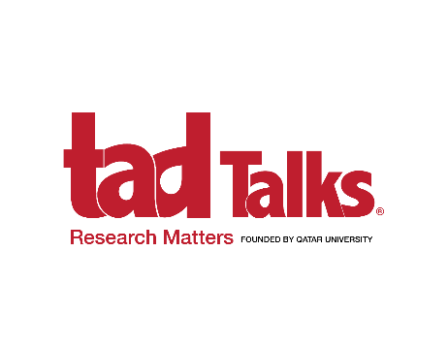

[Event and Brand Permission Form](https://survey.app.uq.edu.au/E129D9FD-154E-467A-B955-9A08695F644A)

To request permission to hold tadTalks and use the tadTalks brand, information, resources and marketing materials please complete the required information.

* Top of Form

1. TITLE

Answer text

1. FIRST NAME

Answer text

1. LAST NAME

Answer text

Top of Form

1. CONTACT NUMBER (please include country code)

Answer text

1. EMAIL

Answer text

~~Bottom of Form~~

~~Top of Form~~

1. UNIVERSITY / ORGANISATION

Answer text

1. UNIVERSITY / ORGANISATION WEBSITE

Answer text

1. COUNTRY

Answer text

Bottom of Form

I agree to host tadTalks as outlined in all materials provided by Qatar University.

I acknowledge that tadTalks is a registered trademark of Qatar University

I confirm that the tadTalks logo and all resources will not be used without the permission of Qatar University and any use of the trademark and resources will comply with the event and brand guidelines.

Top of Form

ACCEPT ALL tadTalks TERMS & CONDITIONS

Bottom of Form

Date

Signature

Please send the form to [tadTalks@qu.edu.qa](mailto:tadTalks@qu.edu.qa)