**Qatar University**

**Community Discounts AGREEMENT**

This COMMUNITY DISCOUNTAGREEMENT hereinafter “Agreement” is made and shall be effective from Day/Month/Yearto 31/12/0000by and between:

____________________ with its business address at _____________________, Doha, Qatar.

And

**QATAR UNIVERSITY**, (hereinafter referred to as “QU”);

____________________ desires to provide discount on specific products/services to QU community members as set out here below and

QU has agreed to promote the above-mentioned discount to their members in accordance with the terms and conditions of this Agreement;

NOW, THEREFORE, it is hereby agreed between the two parties as follows:

1. ___________________ agrees to provide to QU members (i.e. current students, staff, faculty and alumni members only) with:
   1. _____________________________
   2. ______________________________
   3. ______________________________
2. The above-mentioned discount cannot be used in conjunction with any other promotions, discounts or privileges.
3. In order to receive the said discount the QU member must present his/her QU identification to the representative at the time of purchase (sample of current Student ID, current Staff ID, current faculty ID and Alumni membership ID are exhibited in Appendix A herein).
4. In the event that QU learns of a member, who has not received the discount provided for herein QU members will promptly notify ________________ who will investigate the matter and make the best effort to rectify the situation provided that the terms of this Agreement have been honoured.
5. Each party agrees to indemnify and hold the other harmless for any losses, including reasonable attorneys’ fees arising from its wrongful acts or omissions in connection with

its acts or omissions pursuant to this agreement.

1. We agree that either party may terminate the agreement by giving written notice to the other party: for convenience, upon the expiration of at least 7 days’ written notice
2. This agreement shall run for a period of ________________ till ________________

IN WITNESS WHEREOF, the receipt and sufficiency duly acknowledged, the PARTIES or their duly authorized representatives have caused this Agreement to be executed on the day and date first written above:

|  |  |
| --- | --- |
| ____________________________________ | **QATAR UNIVERSITY** |
| Name: | Name: **Buthaina Al Langawi** |
| Title: | Title: Manager of Alumni Relations |
| Date: | Date: |
| Signature: | Signature: |

**APPENDIX A**

Sample of current Student ID, current Staff ID, current faculty ID, and Alumni membership ID

**APPENDIX A**

Samples of current student, staff, Faculty, and Alumni member ID

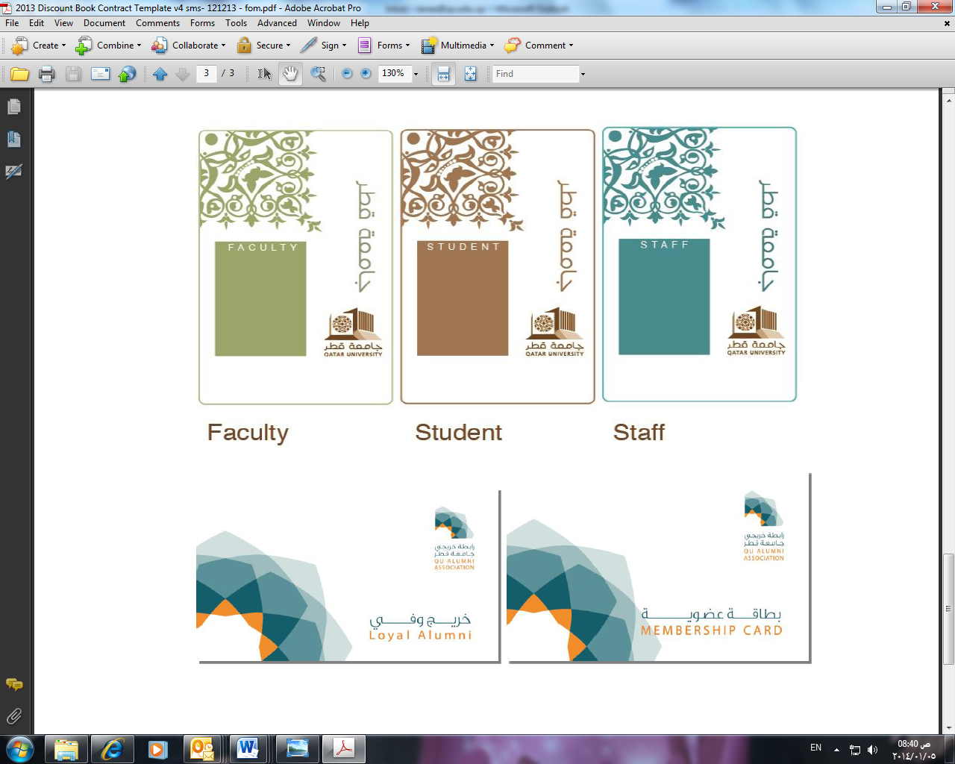

**Alumni Membership**